Ansible document

This document assumes that you have prior knowledge about the Google Cloud Platform (GCP).

Firstly, create a ansible-server VM(Ubuntu 18.04 LTS) and ansible-node VM(Ubuntu 18.04 LTS) and then follow the following steps :-

Configuration for Server Side :-
- Create a new user with the name ansible “sudo adduser ansible”.
- Give sudo permissions to that user by “sudo usermod -aG sudo ansible”.
- Then, login with the ansible user by “su - ansible”.
- Run sudo apt-get update
- Run sudo apt-get install -y ansible
- Run ssh-keygen (For generating key.)
Note :- Don’t set any passphrase for this just press Enter

Configuration for Node Side :-
- Create a new user with the name ansible “sudo adduser ansible”.
- Give sudo permissions to that user by “sudo usermod -aG sudo ansible”.
- Then, login with the ansible user by “su - ansible”.
- Run sudo apt-get update
- Run sudo apt-get install -y python
- Make changes in /etc/ssh/sshd_config file (Change PassowrdAuthentication= yes)
- Then restart sshd service by sudo systemctl restart sshd

Come back to the server side :-

- Add node external (live) IP in /etc/ansible/hosts file by the command.
sudo vi /etc/ansible/hosts

- Add remote user in /etc/ansible/ansible_cfg file (remote_user = ansible) by the command.
sudo vi /etc/ansible/ansible.cfg

- Run sudo ssh-copy-id usernme@IP (eg :- user@123.123.123.123)
It will copy the private key from server side to node side.

- For testing ping the node by ansible -m all ping .

- You can also use for ping node ansible -m ping (nodeIP) .

- Upload the copy.yml file and make a index.html file.

- Make sure that the both files resides in the same directory (/home/ansible)
- 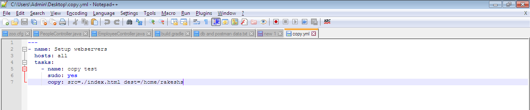

Copy.yml

- Then run ansible-playbook copy.yml .
OR
ansible-playbook copy.yml --extra-vars “ansible_sudo_pass=your_password”

- It will copy the index.html file on to your node machine on same path (/home/user)

Note:- Make sure that the index.html file will only accept the same path on node side as the server side.

